CS-23334 FUNDAMENTALS OF DATA SCIENCE
ASHWIN C 240701058

Experiment 14 Date: 23.10.2025

14. Hypothetical using ANOVA-Test

Aim:
To compare the growth rates of plants under three different fertilizer treatments (Treatment A, B, and C) to determine if there is a significant difference in their mean growth.

Description:
A statistical ANOVA -Test is conducted to determine the growth rates of plants under three different treatments .

Algorithm:

1. Null Hypothesis (H₀): The mean growth rates of plants under all three fertilizer treatments are equal.
2. Alternative Hypothesis (H₁): At least one pair of mean growth rates of plants under different fertilizer treatments are not equal.
3. Samples:
Measure the growth (in centimeters) of 25 plants under Treatment A.
Measure the growth (in centimeters) of 25 plants under Treatment B.
Measure the growth (in centimeters) of 25 plants under Treatment C.

4. ANOVA: Conduct a one-way ANOVA to compare the mean growth rates of plants across the three fertilizer treatments.
5. Decision Rule: Use a significance level of α = 0.05..

Code With Example:

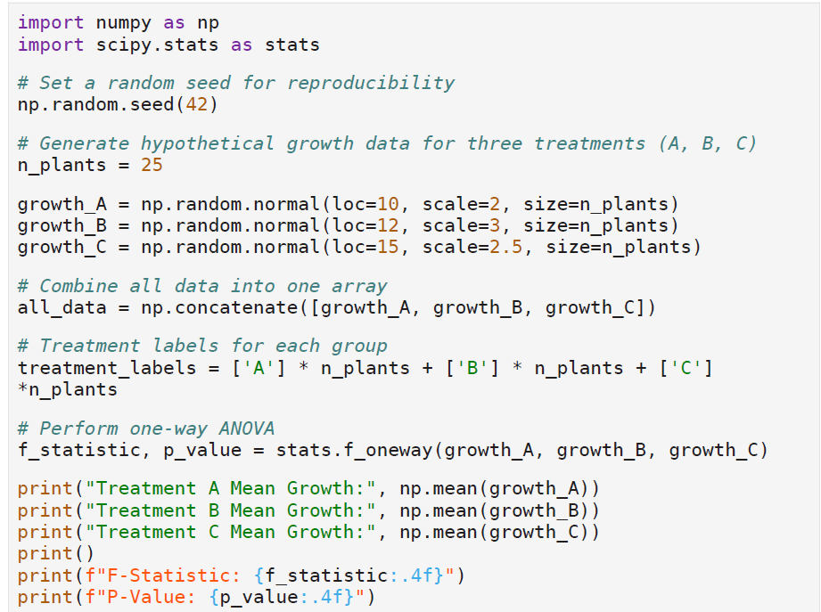

Output:

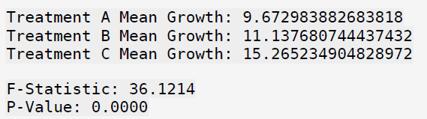

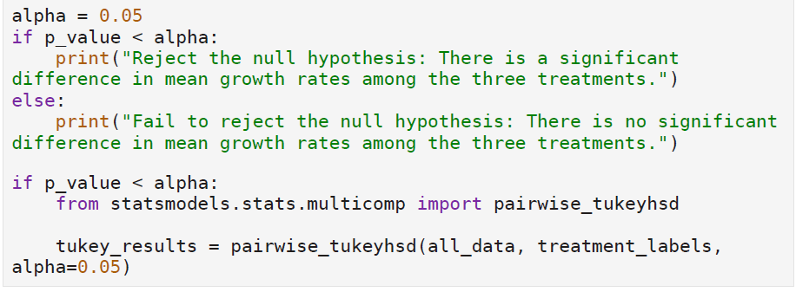

Output:
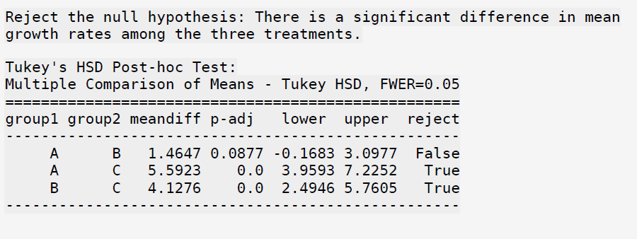

Result:
The Python program to compare the growth rates of plants under three different fertilizer treatments involves conducting an ANOVA test to determine if there is a significant difference in mean growth rates among the treatments was executed.

